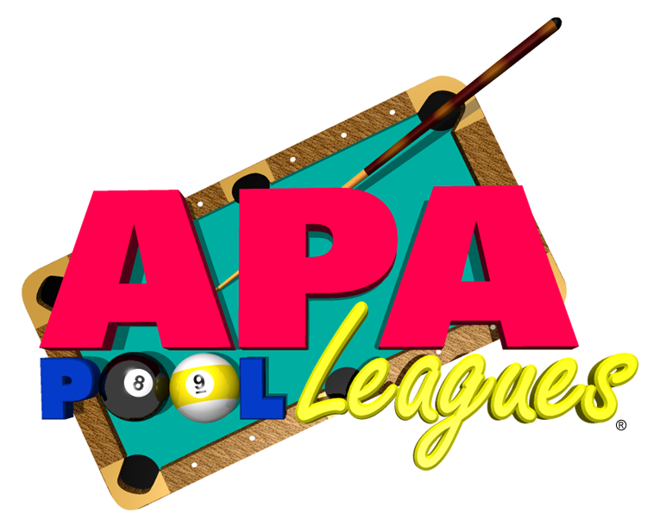

A Pool League is a structured format for amateur players to get together with their friends once per week to play pool! The league incorporates a unique handicapping system so that players of all abilities can compete and win! There’s no better way to improve your pool skills and have fun than by participating in the APA – the world’s largest amateur pool league!

APA members receive a membership kit from the National office to include discounts from National companies. Additionally, as a Central Virginia APA member, you receive discounts from local businesses and special rates to play pool at many of our locations.

In addition to simply having fun, you are playing for the right to represent our area in many formats at the APA Nationals in exciting Las Vegas!

So, please surf our site for lots of helpful information on the league and how you can contact us to become a member and let the fun begin!

