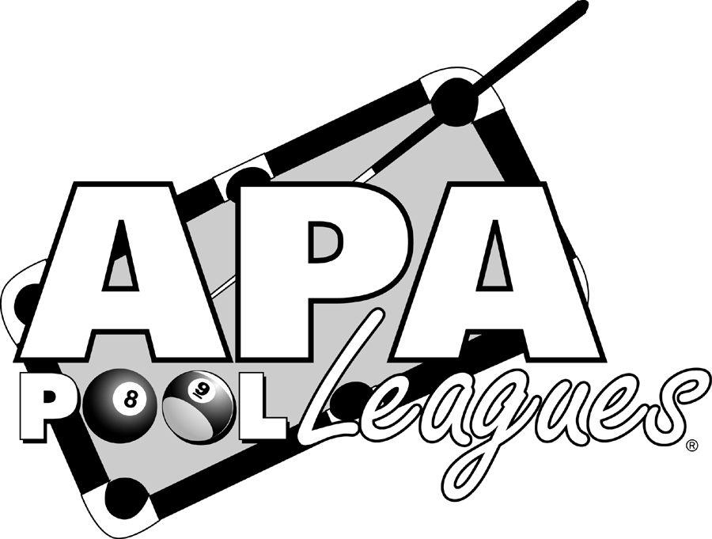 SINGLES QUALIFIERS

WHEN/WHERE: The following SUNDAY at noon at The Playing Field

March 15, 2009

We plan to offer Splash Boards in both 8 & 9-ball, but will run boards based

on the availability and interest of the players. There is no table time for

playing, and your $15 - $30 entry fee could send you to Vegas to become our

next Central Virginia APA Singles Champion! See the National site

(www.poolplayers.com), for more information, and rules of participation (be

sure you are eligible to play)! With many other events going on this session,

the qualifying dates are limited so don’t miss out!

All qualifiers are APA handicapped!

